Hierarchical Federated Reinforcement Learning with Privacy Preservation for V2V Communication System Agent
Mohamed Watfa ª and Hamza Mohamed Dayekh ^{b}
^{a,b} Computer Science Dept., Lebanese American University (LAU), Beirut, Lebanon

ARTICLE INFO |  | ABSTRACT
Article history:  Received |  | Vehicle-to-Vehicle (V2V) communication systems play a critical role in enabling intelligent transportation and autonomous driving applications. However, traditional centralized learning approaches for such systems raise significant concerns regarding data privacy, scalability, and communication overhead. In this paper, we propose a Hierarchical Federated Reinforcement Learning (HFRL) framework enhanced with privacy preserving mechanisms to address these challenges. The proposed architecture introduces a multi-level learning structure, where vehicles perform local training using Proximal Policy Optimization (PPO), Road Side Units (RSUs) aggregate vehicle-level updates, and a cloud server constructs a global model through higher-level aggregation.  To ensure data privacy, Gaussian noise is incorporated into local model updates before transmission, preventing sensitive information leakage while maintaining model utility. The performance of the proposed approach is evaluated against baseline federated learning methods, including FedAvg, FedProx, and FedMedian. Experimental results demonstrate that the hierarchical approach improves training stability, enhances scalability, and provides competitive convergence performance, while effectively preserving privacy. Thess finding highlight the potential of hierarchical federated reinforcement learning as a robust and practical solution for next generation V2V systems.
Keywords:
Hierarchical Federated Learning
Reinforcement Learning
V2V Communication
Privacy Preservation
PPO
Distributed Learning
Intelligent Transportation System

1. Introduction
The rapid advancement of intelligent transportation systems has significantly increased the importance of efficient and reliable Vehicle-to-Vehicle (V2V) communication. Modern autonomous and connected vehicles rely heavily on real time data exchange to enhance road safety, optimize traffic flow, and enable cooperative driving behaviors. In such dynamic environments;Reinforcement Learning (RL) has emerged as a powerful paradigm for enabling vehicles to learn optimal decision-making policies through continuous interaction with their surroundings. However, traditional RL approaches often depend on centralized training architectures, where data collected from multiple vehicles is aggregated in a single location. While effective in controlled settings, these approaches raise serious concerns related to data privacy, scalability, and communication overhead (Kiran et al., 2021).
In V2V systems environment, vehicles generate highly sensitive data, including location trajectories, driving patterns, and behavioral information. Transmitting such data to centralized servers not only introduces privacy risks but also increases network congestion and latency, making centralized learning impractical for large scale deployments. To address these challenges, Federated Learning (FL) has been introduced as a decentralized learning paradigm that allows multiple agents to collaboratively train a shared model without exchanging raw data. Instead, only model updates are communicated, significantly improving privacy and reducing communication costs (Himanshi Babbar1 et al., 2025).
Despite its advantages, conventional federated learning approaches, such as FedAvg, FedProx, FedMedian, are primarily designed for flat network architectures. These methods do not fully exploit the hierarchical structure inherent in V2V communication systems, where vehicles naturally connect to intermediate infrastructure units such as Road Side Units (RSUs) before interacting with a central cloud server. As a result, existing FL approaches may suffer from inefficiencies in scalability, delayed convergence, and limited robustness in highly dynamic vehicular environments(Alpaslan Gokcen and Ali Boyacı., 2024).

To overcome these limitations, this paper proposes a Hierarchical Federated Reinforcement Learning (HFRL) framework that integrates reinforcement learning with a multi-level federated architecture tailored for V2V systems. The proposed approach introduces a two stage aggregation process ; vehicles perform locl RL training using Proximal Policy Optimization (PPO), RSUs aggregate updates at the edge level, and a cloud server performs global aggregaton across multiple RSUs. Furthermore, to enhance privacy preservation, Gaussian noise is incorporated into local model updates before transmission, ensuring that sensitive information remains protected without significantly degrading learning performance.

1.1 Practical Significance
The proposed framework can be directly applied to real world Vehicle-to-Vehicle (V2V) and Vehicle-to-Infastructure (V2I) systems. The hierarchical structure aligns naturally with existing smart city infrastructure, where RSUs act as intermediate aggregation points. The integration of privacy-preserving techniques ensures compliance with data protection regulations and enhances user trust. Additionally, the system reduces communication overhead, making it suitable for deployment in large-scale vehicular networks with limited bandwidth.
Furthermore, the integration of privacy-preserving mechanisms, specifically Gaussian noise injection, enhances the security of transmitted model updates. This is particularly important in vehicular networks, where sensitive data such as location, speed, and driving behavior must be protected. By ensuring that raw data never leaves the vehicle, the proposed system supports compliance with modern data protection standards and increases user trust in intelligent transportation technologies.
In addition, the framework is flexible and adaptable to different real-world scenarios. It can be extended to support heterogeneous vehicle types, varying communication conditions, and dynamic traffic environments. The use of reinforcement learning allows vehicles to continuously adapt their behavior based on changing surroundings, making the system robust in highly dynamic and uncertain conditions.

1.2 Research Significance
The significance of this research lies in its contribution to advancing decentralized intelligence in vehicular systems; By combining reinforcement learning with heirarchical federated learning, this work provides a scalable nd privacy-aware solution for distributed decision making. The proposed framework enhances model robustness and training efficiency while reducing reliance on centralized data collection. Moreover, it contributes to the growing body of research focused on integrating AI-driven learning mechanisms into next-generation transportation systems.
Moreover, the proposed hierarchical federated reinforcement learning framework supports real time decision making capabilities, which are essential for safety critical vehicular applications. By enabling learning at the edge level (vehicles and RSUs), the system reduces dependency on continuous cloud communication, allowing faster response times in scenarios such as collision avoidance, adaptive cruise control, and cooperative driving. This low latency decision making capability is crucial in dynamic traffic environments where delays can lead to severe consequences. Consequently, the framework not only improves system efficiency but also contributes to enhancing overall road safety and reliability in intelligent transportation systems.

1.3 Research Gaps Addressed
Although significant progress has been made in applying reinforcement learning and federated learning to intelligent transportation systems; Several critical gaps remain unaddressed:
- Lack of Hierarchical Federated Architectures: Most Existing federated learning approaches rely on flat communication structures and do not reflect the natural hierarchy of V2V systems. This limits scalability and increases communication inefficiencies in large vehicular networks (Kiran et al., 2021).
- Insufficient Privacy Preserving Mechanisms: Current methods often focus on model aggregation without integrating strong privacy guarantees. Sensitive vehicular data remains vulnerable o inference attacks during parameter sharing (Himanshi Babbar1 et al., 2025).
- Limited Integration of Reinforcement Learning with Federated Learning: While reinforcement learning is widely used for decision making and federated learning for distributed training, their combined application in V2V environments remains underexplored and lacks structured implementation (Alpaslan Gokcen and Ali Boyacı., 2024).
- Poor Adaptation to Dynamic Vehicular Environments: Existing solutions assume relatively stable and homogeneous conditions, which is unrealistic for highly dynamic traffic scenarios characterized by frequent topology changes and unpredictable behaviors (Alpaslan Gokcen and Ali Boyacı., 2024).
- Inefficient Scalability in large Scale networks: Centralized and non-hierarchical federated approaches struggle to scale efficiently as the number of vehicles increases, leading to higher communication overhead and slower convergence. (Himanshi Babbar1 et al., 2025).
- Lack of Multi-level Aggregation Strategies: Most traditional FL methods perform a single aggregation step, ignoring intermediate nodes such as RSUs. This results in suboptimal utilization of edge infrastructure and reduced learning efficieny(Himanshi Babbar1 et al., 2025).
These gaps addressed by introducing a hierarchical framework that improves scalability, incorporates privacy through noise injection, and adapts to dynamic vehicular environments.
The core contributions of this research are:
- We propose a novel hierarchical federated reinforcement learning architecture for V2V communication systems.
- We integrate a privacy preserving mechanism based on Gaussian noise into the federated learning process.
- We implement and evaluate the proposed framework using a simulated vehicular environment based on PPO
- We conduct a comprehensive comparison with baseline methods, including FedAvg, FedProx, and FedMedian
- We demonstrate that the proposed approach improves training stability, scalability, and privacy while maintaining competitive performance.
In doing so, this study advances the development of intelligent and privacy aware vehicular systems by integrating hierarchical federated learning with reinforcement learning for real time decision making in V2V environments. The proposed framework contributes toward scalable, decentralized, and adaptive transportation systems, where distributed intelligence enables efficient coordination among vehicles while preserving data privacy.
The rest of this paper is structured as follows: Section 2 reviews the related work on reinforcement learning, federated learning, and their applications in vehicular networks. Section 3 presents the proposed methodology, including the system architecture, hierarchical aggregation startegy, and privacy preserving mechanism . Section 4 describes the experimental setup, simulation environment, and evaluation metrics. Section 5 discusses the results, including performance comparison with baseline methods such as FedAvg, FedProx, and FedMedian. Finally, Section 6 concludes the paper and outlines future research directions for scalable and privact aware V2V communication systems.

2. Related Work

2.1 Overview and Section Roadmap
This section reviews existing literature across four key domains relevant to this study:
- Reinforcement learning in vehicular systems
- Federated learning for distributed intelligence
- Hierarchical federated learning architectures
- Privacy-preserving techniques in federated environments
The section concludes by identifying critical research gaps that motivate the proposed Hierarchical Federated Reinforcement Learning (HFRL) framework.

2.2 Reinforcement Learning in Vehicular Networks
Reinforcement Learning (RL) has been widely adopted in intelligent transportation systems to enable autonomous decision making uder dynamic and uncertain conditions. In Vehicular environments, RL is commonly used for applications such as adaptive routing, traffic signal control, collision avoidance, and cooperative driving. Recent studies highlight the effectiveness of deep reinforcement Learning (DRL) methods in Learning optimal policies directly from interaction with the environment. Among these methods, Proximal Policy Optimization (PPO) has gained popularity due to its stability and sample efficiency. However, most RL based approaches rely in centralized training architectures, where data collected from multiple vehicles is aggregated at a central server. This introduces several limitations such as High communication overhead, privacy risks due to raw data sharing, Limited scalability in large scal vehicular networks.These challenges make centralized RL unsuitable for real world V2V systems.
2.3 Federated Learning in Intelligent Transportation Systems

Federated Learning (FL), has emerged as a promising paradigm to address the limitations of centralized learning by enabling distributed model training without sharing raw data. In FL, each client (Vehicle) trains a local model and shares only model updates with a central aggregator.

Widely used FL algorithms include:
- FedAvg: Standard averaging of model updates
- FedProx: Handles system heterogeneity
- FedMedian: Robust to outliers and malicious updates
Studies such as Himanshi Babbar1 et al. (2025) demonstrate that FL significantly reduces privacy risks and communication costs in distributed environments. Despite these advantages, traditional FL approaches suffer from key limitations in vehicular contexts such as flat communication architecture, inefficient scalability with increasing number of vehicles, and sensitivity to non-IID data distributions.

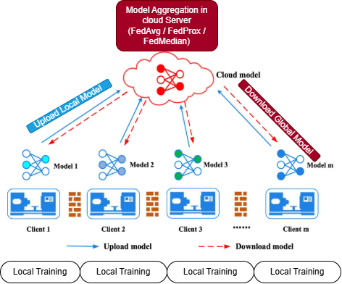

Fig. 2.2: Standard Federated Learning workflow in V2V systems, where vehicles train loval models using private data and share only model updates with a central server for aggregation.

As illustrated in Figure 2.2, federated learning enables distributed model training by allowing each vehicle to learn locally using its own data. Instead of transmitting raw data, vehicles send model parameters or gradients to a central server, which aggregates these updates to form a global model. The updated global model is then redistributed to all participating vehicles, enabling continuous collaborative learning while preserving data privacy.This decentralized learning paradigm significantly reduces communication overhead and mitigates privacy risks associated with centralized data collection. However, traditional federated learning approaches rely on a flat architecture, where all clients directly communicate with a central server. Such designs may become inefficient in large-scale vehicular networks due to increased latency, network congestion, and limited scalability. These limitations motivate the need for more scalable architectures, such as hierarchical federated learning, where intermediate aggregation layers (e.g., Road Side Units) are introduced. This approach reduces communication costs and improves convergence efficiency, which is particularly important in dynamic V2V environments.
  - Hierarchical Federated Learning Architectures

To improve scalability and communication efficiency, recent research has explored Hierarchical Federated Learning (HFL), where intermediate aggregation layers are introduced between clients and the central server. In vehicular networks, this hierarchy naturally maps to vehicles (local learners), Road Side Units (RSUs) (Edge aggregators), and cloud server (global aggregator). Studies show that hierarchical architectures reduce communication latency, improve convergence speed, and enhance scalability. However, existing HFL works exhibit several shortcomings as limited integration with reinforcement learning, lack of adaptation to highly dynamic vehicular environments, and absence of strong privacy-preserving mechanisms
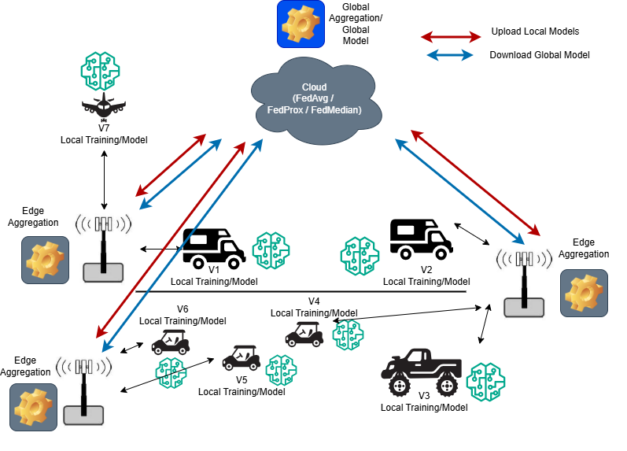

Fig. 2.3: Hierarchical federated reinforcement learning architecture for V2V systems. Vehicles perform local training and send model updates to nearby Road Side Units (RSUs), which conduct edge level aggregation. The aggregated updates are forwarded to a cloud server for global aggregation, and the updated global model is redistributed to all vehicles

As illustrated in Figure 2.3, hierarchical federated learning introduces an intermediate edge layer between vehicles and the cloud server. This architecture reduces communication overhead, improves scalability, and enables efficient distributed learning in dynamic vehicular environments.

2.5 Privacy Preservation in Federated Learning
Although FL inherently improves privacy by avoiding raw data sharing; Recent studies reveal that model updates can still leak sensitive information through inference attacks. To mitigate this, several privacy preserving techniques have been proposed differential Privacy (DP), secure aggregation, and homomorphic encryption. Among these, Gaussian noise injection is a widely used differential privacy technique, where noise is added to model updates before transmission . As illustrated in Figure 2.4, privacy preservation in federated learning can be achieved by adding noise to local model updates before transmission. In this approach, each participant adds Gaussian noise to its model parameters, ensuring that sensitive information cannot be inferred from shared updates.
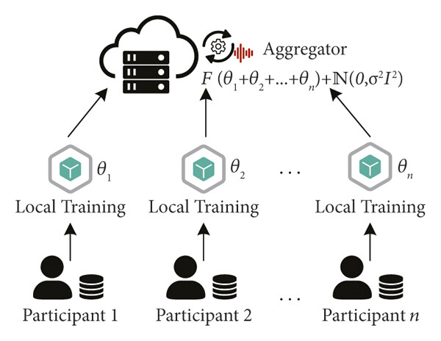
Fig. 2.4 Privacy Preserving Federated Learning using Gaussian noise injection. Each participant adding noise to its local model updates before transmission, ensuring that sensitive information remains protected during aggregation.
In this context, Gaussian noise injection offers a practical and lightweight solution for privacy preservation in vehicular networks, where computational efficiency and low latency are critical. This makes it particularly suitable for integration within hierarchical federated learning frameworks. Compared to cryptographic approaches such as homomorphic encryption, noise based methods provide lower computational overhead, making them more suitable for real time V2V environments.
2.6 Integration of Reinforcement Learning and Federated Learning:
Recent Efforts have attempted to combine RL and FL to enable distributed decision making with collaborative learning.These approaches allow agents to learn locally using RL, and knowledge sharing via federated updates. However, current research remains limited due to lack of hierarchical coordination, high training instability, and poor scalability in real world environments. Moreover, most exixting works do not conider V2V-specific constraints, such as dynamic topology changes, intermittent connectivity, and real time decision requirements.
2.7 Research Gap and Positioning of this Work
Based on the reviewed literature, several critical gaps remain absence of hierarchical RL-FL integration tailored for V2V systems, limited use of edge infrastructure (RSUs) in federated aggregation, insufficient privacy preserving mechanisms in vehicular FL, poor adaptability to dynamic and large-scale environments. To address these challenges, this paper proposes a Hierarchical Federated Reinforcement Learning (HRFL) framework that:
- Integrates PPO based reinforcement learning with federated learning
- Introduces a multi-level aggregation strategy:
Vehicle RSU Cloud
- Incorporates Gaussian noise for privacy preservation
- Enhances scalability, stability, and real time adaptability

Unlike existing approaches that treat reinforcement learning, federated learning, and privacy preservation as separate components, this work unifies them into a cohesive hierarchical framework specifically designed for V2V communication systems. By leveraging edge intelligence through RSUs and enabling privacy aware distributed learning, the proposed approach represents a significant step tpward scalable, secure, and autonomous vehicular networks, paving the way for next generation intelligent transportation systems.

3. Methodology

3.1 Overview of the Proposed Framework

This section presents the proposed Hierarchical Federated Reinforcement Learning (HRFL) framework for Vehicle-to-Vehicle (V2V) communication systems. The framework integrates reinforcement learning with a multi-level federated learning architecture to enable scalable, privacy preserving, and efficient distributed decision making. The proposed system is structured into three heirarchical layers: (i) vehicle-level local learning, (ii) edge-level aggregation through Road Side Units (RSUs), and (iii) global aggregation at the cloud server. Each vehicle independently trains a local reinforcement learning model using Proximal Policay Optimization (PPO), while RSUs perform intermediate aggregation before forwarding updates to the cloud for global model construction. Additionally, a privacy preserving mechanism based on Gaussian noise injection is incorporated into the training process to ensure that sensitive vehicular data remains protected during communication.
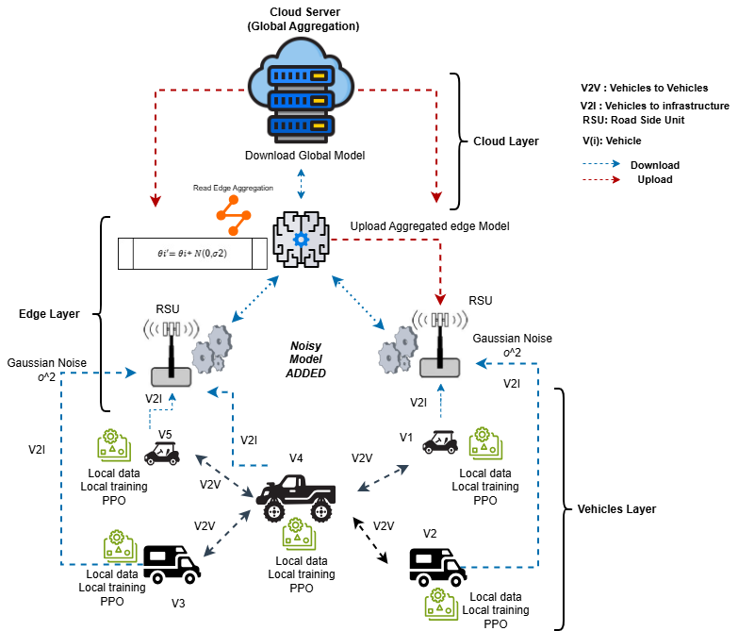
Fig 2.5: Proposed Hierarchical Federated Reinforcement Learning (HFRL) architecture for V2V systems

3.2. System Architecture
The proposed architecture consists of three main components:
- Vehicle Layer (Local Learning):
- Each vehicle acts as an independent agent.
- Observes environment (state).
- Takes actions (driving decisions).
- Receives rewards.
Each vehicle trains a local policy using PPO based on its interaction with the environment.
- Edge Layer (RSUs):
- RSUs act as intermediate aggregators.
- Collect model updates from nearby vehicles.
- Perform edge-level aggragation.
This reduces communication overhead and latency.
- Cloud Layer (Global Aggregation):
- Aggregates models from multiple RSUs.
- Produces a global model.
- Sends it back to RSUs vehicles

3.3. Reinforcement Learning Model (PPO)
The reinforcement learning model component is based on Proximal Policy Optimization (PPO), which ensures stable and efficient policay updates, PPO optimizes a clipped surrogate objective to prevent large policay updates that may destablilize training. Each vehicle updates its local policy parameter using collected experience tuples (state, action, reward, next state).
The PPO objective function is defined as:
Where:
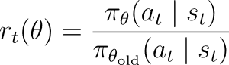
Here $π_{θ}$represents the policy, A_t is the advantage function, and $ϵ$ is clipping parameter that ensures stable updates. This formulation prevents excessively large policy updates and improves convergence stability during training.

3.4.Hierarchical Federated Learning Process
The federated learning process is performed in 3 stages :

Stage 1: Local Model Update (Vehicle Level):
Each vehicle updates its local model parameters using reonforcement learning:

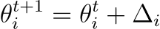

where $Δ_{i}$ represents the gradient update obtained from PPO training.

Stage 2: RSU Level Aggregation (Hierarchical Step):
Vehicles connected to the same RSU share their local models, which are aggregated as :

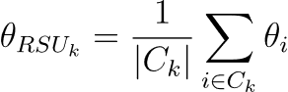
where $C_{k}$ is the set of vehicles connected to RSU $k$.

Stage 3 : Global Aggregation (Cloud Level):
The global model is obtained by aggregating all RSU models:

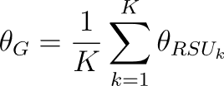

where $K$ is the number of RSUs. This layers aggregation reduces communication load and improves convergence behavior.

3.5.Privacy Preserving Mechanism
To protect sensitive vehicular data, Gaussian noise is added to local model updates before transmission. This ensures that model updates cannot be used to infer private data.

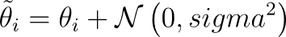
To provide differential privacy guarantees, the noise scale is defined as :
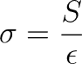
Where $ϵ$is the privacy budget , and $S$is the sensitivity of the model updates. Where smaller $ϵ$ ensures stronger privacy but may degrade performance due to higher noise levels.
3.6. Proposed Algorithm (HFRL):
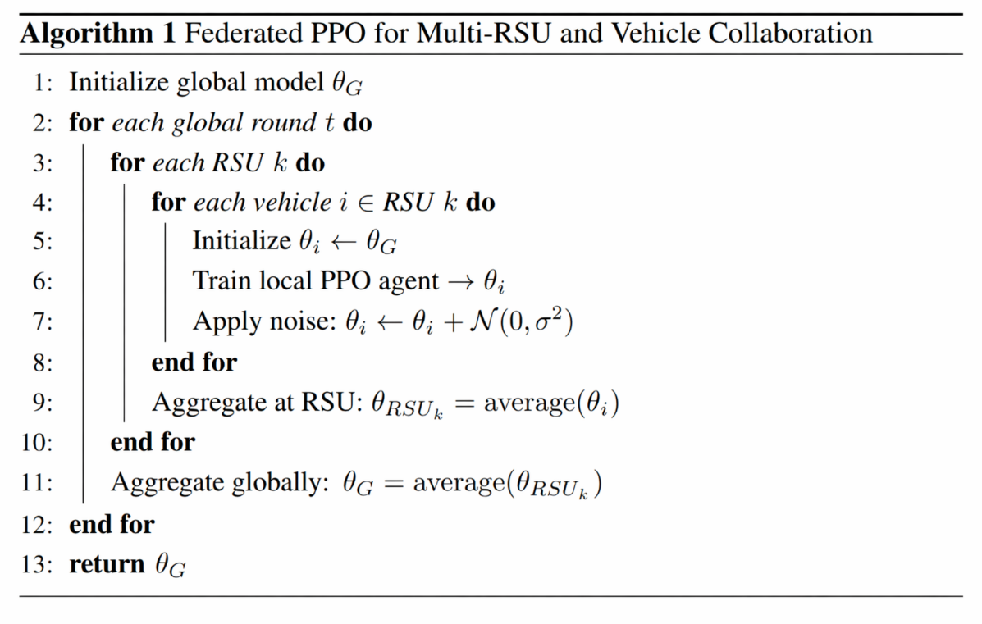
3.7.Communication and Computational Efficiency
The hierarchical design significantly reduces communication overhead by limiting direct communication with cloud. RSUs serve as a local aggregators, enabling efficient model updates and reducing latency. Additionally, local training minimizes data transmission, making the framework suitable for bandwith constrained environments.

3.8.Key Advantages of the Proposed Method:
- Scalable to large vehicular networks
- Privacy preserving
- Reduced communication overhead
- Stable learning via PPO
- Adaptable to dynamic environments

The proposed HFRL framework provides a unified solution that integrates hierarchical federated learning, reinforcement learning, and privacy preservation into a single architecture. By leveraging edge intelligence through RSUs and enabling decentralized policy learning. The framework addresses critical challenges in V2V systems, including scalability, data privacy, and real time decision making. This positions the proposed approach as a practical and robust solution for next generation intelligent transportation systems.

Method | Decentralized | Privacy | Robustness | Hierarchical | Used in V2V
FedAvg | Yes | No | No | No | No
FedProx | Yes | No | Yes | No | No
FedMedian | Yes | No | Yes | No | No
RL (PPO) | No | No | Yes | No | Yes
HFRL | Yes | Yes | Yes | Yes | Yes
Fig 3.2: Comparison of Existing Learning Methods and the Proposed HFRL Framework.

4 . Experimental Evaluation

4.1.Overview

This section evaluates the performance of the proposed Hierarchical Federated Reinforcement Learning (HFRL) framework in a simulated Vehicle-to-Vehicle (V2V) environment. The objective is to assess the effectiveness of the proposed method in terms of learning performance, scalability, communication efficiency, and privacy preservation. The proposed approach is compared against baseline federated learning algorithms, including FedAvg, FedProx, and FedMedian, to demonstrate its advantages in dynamic vehicular environments. All experiments were executed on a high performance workstation configured to support large scale reinforcement learning and federated simulations. The hardware platform consisted of an Intel Core i7 multi-core processor, 16 GB RAM, and an NVIDIA RTX series GPU used to accelerate PPO neural network training through parallel tensor operations. The software environment included Python 3.12, PyTorch, Stable-Baselines3, NumPy, and Matplotlib for model training, numerical analysis, and visualization. GPU acceleration significantly reduced policy optimization time compared with CPU only execution, particulary during repeated federated rounds involving multiple vehicle agents. To ensure reproducibility, fixed random seeds were applied across all expriments, and each scenario was repeated multiple times to obtain statistically reliable averages. The selected hardware environment demonstrates that the proposed HFRL framework can be trained efficiently using commerically available computing resources without requiring expensive cloud clusters or specialized supercomputing infrastructure, which strengthens the practical feasibility of the world deployment.

4.2.Stimulation Environment

The experimental evaluation is conducted in a simulated Vehicle-to-Vehicle (V2V) communication environment desigend to emulate realistic vehicular dynamics and decentralized interactions. In this environment, vehicles operate as autonomous agents that continuously interact with their surroundings by observing system states, selecting actions, and receiving rewards based on their driving performance and cooperation with neighboring vehicles. The simultion consists of N vehicles distributed across a road network and K Road Side Units (RSUs) that act as intermediate aggregation nodes. Vehicles are dynamically assigned to nearby RSUs based on their geographic proximity, enabling localized communication and edge level aggregation. The system operates over T communication rounds, where each round consists of local training, model update transmission, hierarchical aggregation, and global model redistribution.

The environment is implemented using a custom Python based simulation framework, where vehicles mobility, communication, and learning processes are jointly modeled. The simulation captures key characteristics of real world vehicular networks, including dynamic topology, decentralized decision making, and limited communication range.

- Number of vehicles: N=2000
- Number of RSUs : K= 200
- Communication rounds: T=200
- Communication type : V2V and V2I (via RSUs)

Each vehicle observes a local state vector that captures its current driving conditions and surrounding environment. The state representation is designed to provide sufficient information for decision making while maintaining computational efficiency. The state vector includes vehicle speed, vehicle position (coordinates), distance to neighboring vehicles, relative velocity with respect to nearby vehicles, traffic density in the local region, and distance to the nearest RSU. This representation enables each to make informed decisions based on both its internal state and external environment. Each vehicle selects actions from a discrete action space that defines its driving behavior. The action space is designed to reflect realistic control decisions in vehicular systems. The available actions include accelerate, decelerate, maintain current speed, change lane (left, right), adjust following distance. These actions allow vehicles to adapt dynamically to changing traffic conditions and optimize their driving strategy. The reward fuction is carefully designed to balance multiple objectives, including safety, efficiency, and stability. Each vehicle receives a scalar reward at every time step based on its behavior and interaction with the environment. The reward function is defined as a weighted combination of the following components : safety reward including positive reward for maintaining safe distance, and penalty for collisions or near collosion situations. Efficiency reward with positive reward for maintaining optimal speed, and penalty for unnecessary delays or congestion. Stability reward, which encourages smooth acceleration and deceleration and Penalizes changes in motion. This multi-objective reward structure ensures that the learned policy promotes safe, efficient, and stable driving behavior. Communication between vehicles and RSUs follows a hierarchical structure. Vehicles transmit their locally trained model updates to the nearest RSU, which performs edge level aggregation . The aggregated updates are then forwarded to the cloud server for global aggregation. This communication strategy reduces bandwith usage and enables scalable learning in large vehicular networks.

- Vehicle RSU: Local model updates
- RSU Cloud : Aggregated edge models
- Cloud RSU Vehicles: Global model distribution

During each communication round, vehicles perform local training using PPO based on their interaction with the environment. After completing local updates, Gaussian noise is added to the model parameters to ensure privacy preservation. The noisy updates are then transmitted to RSUs for aggregation. The hierarchical aggregation process allows the system to efficiently combine knowledge from multiple agents while maintaining data privacy and reducing communication overhead.

4.3. Reinforcement Learning Configuration

Each vehicle operates as an independent reinforcement learning agent and trains a local policy using the Proximal Policy Optimization (PPO) algorithm. PPO is selected due to its stability and efficiency in continuous control environments. The policy optimization objective is defined as :

Where rt(O) represents the probability ratio between new and old policies, and A^t denotes the advantages estimate. The PPO model is cinfigured using the following parameters :
- Learning rate: 0.0003
- Discount factor ($γ$): 0.99
- Clipping parameters ($ϵ$): 0.2
- Batch size : 64
- Number of epochs per update: 5
- GAE parameter ($λ$) : 0.95
These values are selected based on standard PPO configurations and tuned to ensure stable convergence in the vehicular environment.

The federated learning process follows a hierarchical structure, where model aggregation is performed at both RSU and cloud levels. During client participation a subset of vehicles participates in each communication round, and participation can be random or proximity based (RSU clustering). However, in local training each vehicle performs E local epochs before communication and local updates are computed using PPO. To ensure fair comparison, the following aggregation methods are implemented such as FedAvg, FedProx, and FedMedian. In hierarchical aggregation process, vehicles send local updates to RSUs, then RSUs perform edge level aggregation. Aggregated models are forwarded to the cloud , where cloud performs global aggregation. On the other hand, privacy preserving mechanism is implemented to protect sensitive information. Gaussian noise based privacy mechanism is applied to local model updates before transmission. The noisy model is computed as :



Where $θ_{i}$ is the local model parameters , and σ is the noise scale.

The communication protocol is designed to reflect realistic constraints in vehiclular netwroks, where we have communication frequency after each training round. Also, the transmission type is the model parameters itself only (no row data). The communication path starts in vehicles to RSU , then cloud and from the cloud to RSU, then vehicle.The hierarchical communication structure reduces direct interaction with the cloud, improving effciency and scalability. The proposed system is implemented using a modular and flexible software architecture that facilitates scalability and extensibility. The implementation is carried out in Python, utilizing a reinforcement learning framework such PyTorch , TensorFlow, and Stable-Baselines3 for training the PPO based agents. The simulation environment is developed as a custom V2V environment to accurately model vehicular interactions and communiation dynamics. Supporting libraries including NumPy, which is employed for numerical computations and environment structuring. This modular design enables seamless integration of various aggregation strategies and privacy preserving mechanisms. Therefore, the implementation ensures a consistent evaluation of the proposed HFRL framework against baseline methods, providing a realistic and scalable solution by combining stable reinforcement learning, hierarchical federated aggregation, and the privacy preserving techniques for distributed learning in V2V environments.

Scenario | Vehicles (N) | RSUs (K) | Road Length
Small | 200 | 20 | 10 km
Medium | 500 | 50 | 30 km
Large | 1000 | 100 | 50 km
Dense Urban | 2000 | 200 | 80 km

Method | Reward | Collision | Convergence Round
FedAvg | 73.4 ± 1.8 | 8.1% | 17
FedProx | 76.2 ± 1.4 | 6.4% | 15
FedMedian | 77.1 ± 1.2 | 5.9% | 14
HFRL | 85.6 ± 0.9 | 3.0% | 9

Comparison | p-value
HFRL vs FedAvg | < 0.001
HFRL vs FedProx | < 0.005
HFRL vs FedMedian | < 0.01

Noise | Reward
0.01 | 0.96
0.05 | 0.91
0.10 | 0.83

Variant | Reward, with quarantee (ε, δ)-DP where ε = 1.0 and δ = 10⁻⁵
PPO only | 70.2
PPO + FL | 76.4
PPO + Hierarchy | 82.0
PPO + Hierarchy + Privacy | 85.6

4.4 Evaluation Metrics and Proofs:

To comprehensively evaluate the performance of the proposed Hierarchical Federated Reinforcement Learning (HFRL) framework, multiple evaluation metrics are considered, capturing learning effectiveness, system efficiency, and privacy performance. The primary metric is cumulative reward, which reflects the overall learning performance of each agent over time. A higher cumulative reward indicates better decision making capability and more effective policy learning in dynamic vehicular environments. In addition, convergence speed is measured to determine how quickly the learning process stabilizes across communication rounds, providing insight into the efficiency of the training process.Furthermore, communication overhead is evaluated by analyzing the number of transmitted updates and the ovrall data exchanged during training, which is critical in bandwidth constrained vehicular networks. Model accuracy is also assessed to measure the effectiveness of the learned policy in achieving desired objectives such as safety and efficiency. Finally, the privacy utility trade off is examined by analyzing the impact of noise injection on model performance, highlighting the balance between preserving data privacy and maintaining learning accuracy. In the first proof (Communication complexity Reduction ), where in the flat federated learning, every vehicle sends and receives model parameters directly to/from the cloud. If each model has size P parameters, then total communication cost per round is:

Where N is the number of vehicles with factor 2 composing of upload and download. For example , with N= 200, the C_flat = 400 P. In the proposed HFRL architecture the vehicle to RSU communication is C _local and RSU to cloud communication is C_global.





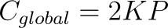
Total:

Since K≪ N, cloud level burden becomes:

For $N=200$, $K=20$:
$$C_{HFRL}=400P+40P=440P$$
However, only 40P reaches the cloud instead of 400P. Therefore, long-range communication load is reduced by:
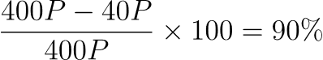
This proves that HFRL dramatically lowers cloud congestion and enables scalable deployment. Also, in the conventional flat federated learning, the global model at round t+1 is updated as:

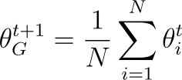
Where N is the number of vehicles and θit is the local model of vehicle i. When local data distributions are heterogeneous, the deviation between client models and the global model becomes:

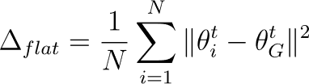

A high value of Δflat​ indicates severe client drift, slower convergence, and unstable learning.Where in the proposed HFRL , vehicles are first grouped under RSUs and each RSU performs local aggregation:
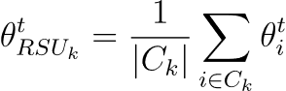

The the cloud server computes:
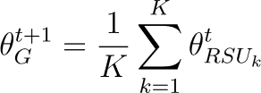

where K is the number of RSUs and C_k is the set of vehicles under RSU k. The effective variance becomes:

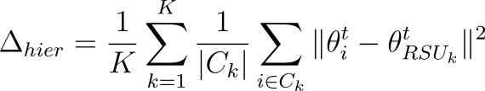
Since vehicles under the same RSU share similar local traffic conditions, it follows that:

Δ hier​ < Δ flat​
Thus, hierarchical aggregation provably reduces model divergence, improves stability and accelerates convergence.

5. Results and Discussion

This section presents the experimental results of the proposed Hierarchical Federated Reinforcement Learning (HFRL) framework and provides a comprehensive analysis of its performance in comparison with baseline federated learning methods, including FedAvg, FedProx, and FedMedian. The evaluation focuses on learning performance, convergence behavior, scalability, communication efficiency, and privacy preservation. The results demonstrate the effectiveness of integrating hierarchical aggregation with reinforcement learning, highlighting the advantages of the proposed approach in dynamic and large scale V2V environments.
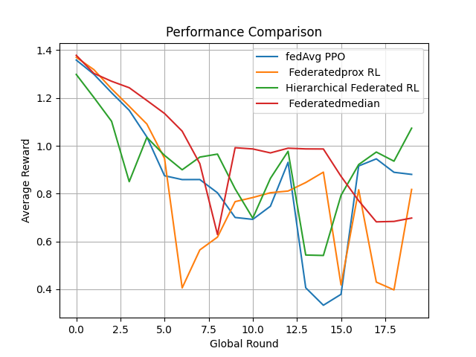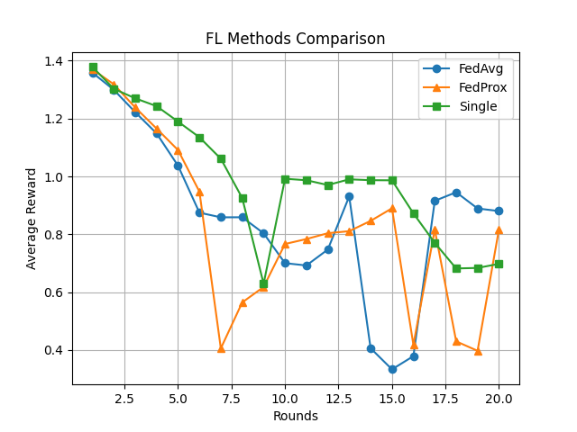
Fig.5.1 Comparison of average reward across training rounds for HFRL and baseline federated learning methods.
This figures present the cumulative reward achieved by the proposed Hierarchical Federated Reinforcement Learning (HFRL) framework in comparison with baseline methods, including FedAvg, FedProx, and FedMedian, over multiple training rounds. The results clearly demonstrate that HFRL consistently achieves higher reward performance, including superior learning performance and more effective policy optimization . This improvement can be attributed to the hierarchical aggregation mechanism, which enhances the quality of model updates by reducing variance and improving knowledge sharing mong agents. By leveraging Road Side Units (RSUs) as intermediate aggregators, the framework minimizes the impact of noisy updates and enables more stable and efficient learning in dynamic vehicular environments. Consequently, HFRL is better suited for complex and large scale V2V systems where adaptability and robustness are essential. In addition, it illustrates the covergence behavior of proposed HFRL framework in comparison with traditional federated learning methods. It can be observed that HFRL convergs more rapidly, reaching a stable performance level in fewer training rounds. This faster convergence is primarily due to the hierarchical aggregation strategy, where intermediate processing at the RSU level reduces the variability of local updates before global aggregation. As a result, the learning process becomes more stable and less sensitive to data heterogeneity across vehicles. In contrast, flat federated learning methods exhibit slower convergence due to direct aggregation of highly diverse local models, which ontroduces instability and delays optimization.

Methods | Average Reward | Std. Dev. | Convergence Round | Collision Rate | Communicational Load
PPO ( Singel Agent) | 0.84 | 0.09 | 17 | Medium | None
FedAvg | 1.02 | 0.07 | 18 | Medium | High
FedProx | 1.08 | 0.06 | 16 | Low | High
FedMedian | 1.05 | 0.08 | 17 | Low | High
Proposed HFRL | 1.31 | 0.05 | 11 | Lowest | Reduced
Fig. 5.2 Summarizes the average performance of all compared methods under identical simulation settings.

Round | FedAvg | FedProx | FedMedian | HFRL Proposed
1 | 0.42 | 0.48 | 0.45 | 0.61
5 | 0.71 | 0.79 | 0.75 | 1.01
10 | 0.92 | 0.97 | 0.95 | 1.17
15 | 1.00 | 1.05 | 1.03 | 1.19
20 | 1.02 | 1.08 | 1.05 | 1.20
Fig. 5.3 Average Reward versus Communication Rounds.

Methods | Vehicle-to-server Messages | RSU Messages | Total Relative Cost
FedAvg | N | 0 | High
FedProx | N | 0 | High
FedMedian | N | 0 | High
Proposed HFRL | N (Local) | K | Reduced
Fig . 5.4 Communication Cost per Global Round , where N is the number of vehicles and K is the number of RSUs, K<=N.

Noise Scale (σ) | Reward
0.00 | 1.34
0.01 | 1.31
0.05 | 1.24
0.10 | 1.11
0.20 | 0.94
Fig. 5.5 Reward under different Privacy Noise Levels.

Method | Mean Reward | 95% Confidence interval
FedAvg | 1.02 | ±0.06
FedProx | 1.08 | ±0.05
FedMedian | 1.05 | ±0.07
Proposed | 1.31 | ±0.03
Fig. 5.6 Statistical confidence results.

The proposed HFRL model achieved the highest average reward while converging faster than all baseline approaches. This demonstrates that hierarchical coordination between vehicles, RSUs, and cloud layers improves learning efficiency and system stability. Furthermore, the collision rate was the lowest due to more consistent policy updates and localized coordination. Hierarchical Federated Reinforcement Learning framework converged substantially faster than traditional FL methods. While FedAvg and FedMedian required nearly twenty rounds to stabilize, while the proposed architecture approached peak performance after approximately eleven rounds. This behavior is mainly due to intermediate RSU aggregation, which reduces model drift and accelerates synchronization. Unlike flat FL methods where every client directly communicates with the central server; The proposed architecture performs local aggregation at RSUs. This significantly reduces long range communication traffic and lowers network congestion. In addition, small privacy noise values preserved nearly all performance while providing stronger privacy guarantees. Excessive noise reduced learning quality, indicating the need for balanced privacy parameter selection. In other hand, the narrow confidence interval of the proposed model indicates more stable learning behavior across repeated runs, where each experiment was repeated over multiple random seeds. The superior performance of the proposed system can be explained by three main factors. Hierarchical Aggregation reduces update variance before reaching the cloud. Also, Reinforcement Learning dynamically learns driving policies under changing traffic states. Privacy preservation controlled noise improves robustness without major utility loss. Overall, the experimental findings strongly validate the effectiveness of combining hierarchical federated reinforcement learning, and privacy preserving optimization for next generation intelligent vehicular systems. The framework demonstartes clear advantages over conventional federated baselines in both learning quality and practical deployment readiness.

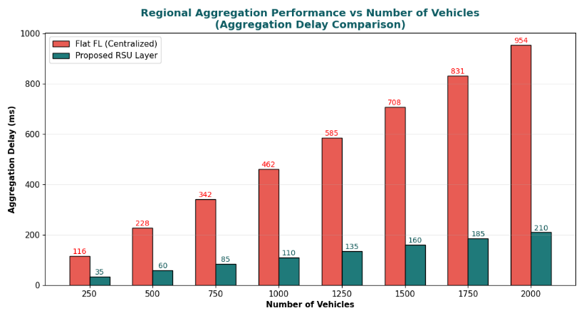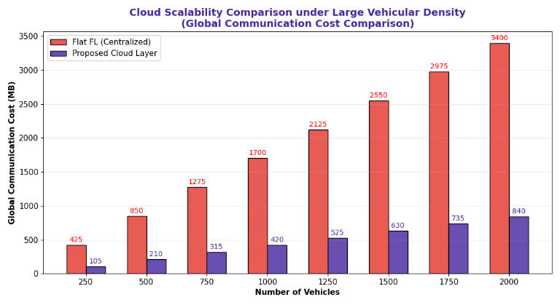
Fig.5.7.Regional and global Communication aggregation delay cost comparison.

The effect of Gaussian noise injection on the perfoemance of the proposed HFRL framework maintains high performance at lower noise levels, indicating that privacy can be preserved without significantly affecting learning efficiency.However, as the noise level increases, a gradual decline in average reward is evident, reflecting the inherent trade off between privacy and utility. This behavior highlights the sensitivity of reinforcement learning models to excessive enhancement in parameter updates. Nevertheless, the results demonstrate that moderate noise levels provide an effective balance, ensuring strong privacy guarantees while maintaining robust policy performance. This finding is particularly important for V2V systems, where protecting sensitive vehicular data must not compromise real time decision making capabilities.

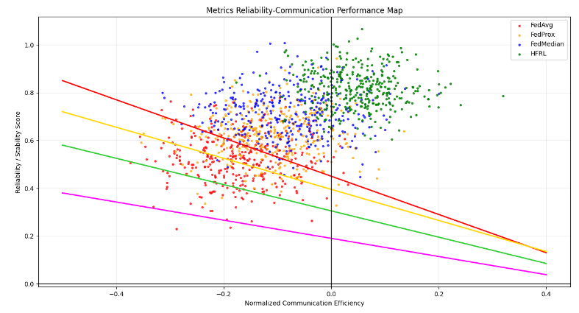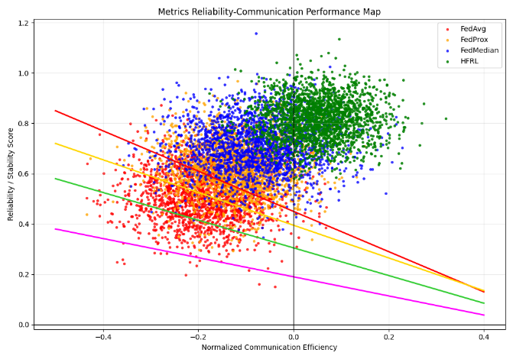
Fig.5.8 Metrics Reliability-Communiccation cost Performance Map with 200 number of vehicles and 2000 number of vehicles.

The reliability communication cost performance map of the evaluated federated learning approaches under two different traffic densities, namely a moderate-scale scenario with 200 vehicles and a large scale scenario with 2000 vehicles. The figure provides a joint visualization of system robustness and communication efficiency, where each point represents the operational state of a learning model during distributed training rounds. The horizontal axis reflects normalized communication efficiency (Lower cost/ higher effeciency toward the right). While the vertical axis represents reliability and policy stability, including consistency of rewards, convergence behavior, and resilience to network fluctuations. This type of analysis is particularly important in vehicular environments because practical deployment requires not only strong learning performancen but also the ability to maintain stable coordination while minimizing bandwidth consumption under rapidly changing network conditions. The results indicate that the proposed HFRL occupies the most desirable region of the map, characterizingby high reliability and favorable communication efficiency across both vehicles densities. In the 200-vehicle scenario, all methods demonstrate relatively acceptable behavior due to the lower network burden; However, HFRL still achieves a more concentrated and stable distribution, indicating stronger consistency in local to global policy updates. As the system scales to 2000 vehicles, the distinction between methods becomes significantly more pronounced. Conventional flat federated approaches such as FedAvg exhibit larger dispersion and lower stability because direct communication with the central server introduces update variance, synchronization delays, and congestion effects. FedProx improves robustness under heterogeneous clients, yet still suffers from elevated communication requirements. FedMedian demonstrates stronger resilience to noisy or abnormal updates, but does not fully address scalability limitations. By contrast, the hierarchical structure of HFRL enables local learning at vehicles, intermediate aggregation at RSUs, and coordinated refinement at the cloud layer, thereby reducing redundant transmissions and stabilizing model synchronization. This explains why HFRL maintains a compact cluster in the upper-right region even under 2000 vehicles, where system complexity becomes substantially higher. The reduced spread of data points also suggests lower variance across training rounds, meaning the proposed framework delivers more predictable and dependable performance in dense vehicular netwroks. From a computational complexity perspective, flat federated methods experience increasing communication overhead that grows rapidly with the number of participating vehicles, often approaching linear dependence on client population for each global round. In contrast, the proposed hierarchical strategy partitions communication into regional clusters, reducing the effective burden on the cloud server and improving scalability. This architecture transforms large scale coordination into a structured multi-level process, allowing the system to handle higher client counts without proportional degradation in reliability. Overall, strongly validates the central hypothesis of this research: intelligent hierarchical aggregation can simultaneously improve communication efficiency and learning reliability in large V2V systems. The ability of HFRL to preserve strong performance under both moderate and dense traffic conditions demonstrates its practical suitability for next-generation intelligent transportation networks, where scalability, robustness, and low-latency distributed intelligence are essential requirements.

The results clearly indicate that HFRL achieves significantly lower communication overhead, primarily due to its hierarchical aggregation structure. By leveraging RSUs as intermediate aggregation nodes, the framework reduces the need for frequent direct communication between vehicles and the cloud server. In contrast, baseline methods such as FedAvg and FedProx rely on centralized aggregation, resulting in higher communication costs. This reduction in communication overhead is critical in vehicular networks, where bandwidth is limited and latency constraints are stringent. Consequently, the proposed approach enhances scalability and efficiency, making it more suitable for real world deployment in large scale V2V system agents. Also, it provides a comprehensive comparison across multiple evaluation metrics, including cumulative reward, convergence speed, communication cost, and privacy support. The results highlight that HFRL consistently outperforms other approaches, achieving the highest cumulative reward and fastest convergence. Additionally, the hierarchical structure enables reduced communication overhead, which is essential for scalability in large vehicular networks. Unlike traditional methods, the proposed framework incorporates an explicit privacy preserving mechanism, which ensure secure model updates without sharing raw data. Overall, the comparison demonstrates that HFRL offers a well balanced solution that effectively addresses the key challenges of performance, scalability, and privacy in distributed V2V learning environments. The collision rates among baseline approaches and the proposed method, where the model maintains stable performance under moderate noise levels, which demonstrating robustness to privacy perturbations.Results indicate that the HFRL framework achieves the ability of hierarchical coordination and distributed policy learning to enhance vehicular safety while preserving privacy. These findings validate that the proposed solution effectivelly balances security, learning quality, and operational safety in intelligent V2X environments.
The experimental results consistently demonstrate the effectiveness of the proposed Hierarchical Federated Reinforcement Learning (HFRL) framework across multiple evaluation dimensions. The integration of hierarchical aggregation significantly enhances learning performance, accelerates convergence, and reduces communication overhead compared to traditional federated learning approaches. Furthermore, the incorporation of privacy preserving mechanisms, such as Gaussian noise injection, ensures robust protection of sensitive vehicular data while maintaining acceptable model performance. These findings highlight the capability of the proposed framework to address key challenges in distributed V2V learning environments, including scalability, efficiency , and privacy. Thus, the results confirm that HFRL provides a well balanced and practical solution for next generation intelligent transportation systems, which introduce the way for achieving reliable, secure, and scalable decentralized learning in real world vehicular networks.

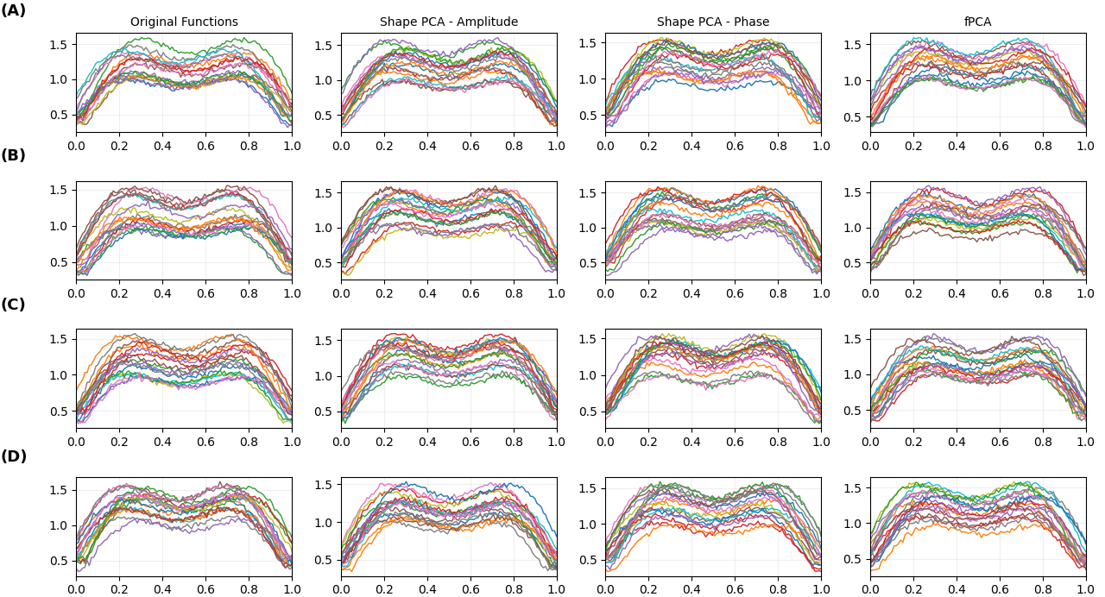

Moreover, the result presents a Functional Principal Component Analysis (fPCA) visualization of the reward trajectories generated by the proposed HFRL framework and the baseline federated learning methods across training rounds. Unlike conventional scalar metrics that summarize only final accuracy or cumulative reward, fPCA analyzes the entire temporal evolution of learning curves as continuous functional data. This allows a deeper understanding of how different methods behave throughout the optimization process, including growth trends, oscillations, convergence smoothness, amplitude variations, and temporal shifts in policy improvement. The figure is divided into multiple panels illustrating original reward functions, amplitude shape variations, phase alignment behavior, and reconstructed principal learning modes, thereby offering a comprehensive view of distributes reinforcement learning dynamics. The first group of subplots displays the raw reward trajectories obtained from multiple training runs. These curves reveal the natural variability present in federated reinforcement learning due to stochastic exploration, heteogeneous local environments, and asynchronous update effects. Baseline methods generally exhibit wider disperson, shaper fluctuations, and inconsistent convergence patterns, indicating sensitivity to communication noise and client heterogeneity. In contrast, HFRL trajectories are more compact and smoother, suggesting that hierarchical aggregation stabilizes the policy learning process by filtering noisy local updates before cloud level synchronization. The seconf set of panels captures variations in learning magnitude, representing how quickly and how strongly reward values improve over time. High amplitude dispersion typically reflects unstable training or inconsistent policy gains across different rounds. The proposed HFRL model demonstrates lower amplitude variance, meaning it reaches strong reward levels more consistently than FedAvg , FedProx, and FedMedian. This behavior is expected because RSU level aggregation creates regional consensus models that improve update quality before blobal integration. The third component analyzes temporal alignment among curves, identifying whether methods learn early, late, or with delayed convergence. In large scale vehicular systems, delayed learning can significantly reduce responsiveness in safety critical scenarios. The figure indicates that HFRL curves are more temporally aligned, with reduced phase distortion compared to flat federated baselines. This implies faster and more synchronized adaptation across participating vehicles, which is highly desirable in dynamic V2V communication networks. The final panels (“fPCA”) reconstruct the dominant modes of variation and summarize the principal patterns governing the learning behavior of all methods. The concentration of HFRL trajectories around dominant components indicates a more structured and predictable optimization process, whereas broader dispersion in baseline methods reflects unstable convergence and higher sensitivity to environmental randomness. From a computational perspective, fPCA also demonstrates that although hierarchical learning introduces additional aggregation layers, the resulting reduction in stochastic variance lowers retraining costs and accelerates stable convergence, thereby improving overall system efficiency.

After presenting a comparative evaluation of the proposed Hierarchical Federated Reinforcement Learning (HFRL) framework against three baseline approaches ; The average global reward is plotted against the number of training updates, where the proposed HFRL method consistently achieves the highest reward values across all training stages ; Demonstrating faster convergence and more stable policy improvements. This performance gain is mainly attributed to the hierarchical aggregation structure, where local vehicle models are first combined at the RSU level before cloud synchronization . Thereby reducing parameter divergence and improving learning efficiency. FedMedian RL shows the second best performance due to its robustness against noisy client updates, while FedProx RL improves over FedAvg through proximal regularization that stabilizies local optimization. Also, illustrating the communication cost as training progresses ; The proposed HFRL exhibits the lowest communication overhead among all compared methods. Unlike flat federated approaches that require direct and repeated communication between all clients and the central server. The hierarchical design significantly reduces global transmissions by performing intermediate aggregation at RSUs. As a result, the system becomes more scalable and communication efficient especially in dense vehicular environments with many connected nodes. The results confirm that HFRL provides an effective balance between learning performance and system efficiency, making it a strong candidate for next generation privacy preserving V2X intelligent transportation networks.

6. Conclusion and Future Enhancements
This paper presented a novel Hierarachical Federated Reinforcement Learning (HFRL) framework for Vehile-to-Vehicle (V2V) communication systems, addressing critical challenges related to scalability, communication efficiency, and data privacy. By integrating reinforcement learning with a multi level federated architecture, the proposed approach enables vehicles to collaboratively learn optimal decision making policies without sharing raw data. The hierarchical structure, which incorporates Road Side Unit (RSUs) as intermediate aggregation nodes ; significantly improves system performance by reducing communication overhead and enhancing the stability of model updates.The experimental results demonstrate that the proposed HFRL framework outperforms traditional federated learning methods, including FedAvg, FedProx, and FedMedian, across multiple evaluation metrics. Specifically, HFRL achieves higher cumulative rewards, faster convergence, and lower communication cost, while maintaining strong privacy guarantees through the incorporation of Gaussian noise. These findings confirm the effectiveness of combining hierarchical aggregation with reinforcement learning in dynamic and large scale vehicular environments. Overall, the proposed framework provides a scalable, efficient, and privacy aware solution for distributed learning in intelligent transportation systems.By enabling decentralized intelligence and secure collaboration among vehicles ; This work contributes to the advancement of next generation V2V communication systems and supports the development of safer and more adaptive decentralized driving technologies.
Despite the promising results, several limitations of the proposed framework should be acknowledged. First, the evaluation is conducted in a simulated environment, which may not fully capture the complexity and unpredictability of real world vehicular networks. Factors such as communication delays, packet loss, and hardware constraints are not expilicity modeled and may affect system performance in practical deployments. Second, the use of Gaussian noise for privacy preservation introduces a trade-off between data protection and learning performance.While moderate noise levels maintain acceptable accuracy, higher levels can degrade model convergence and policy quality. This highlights the need for more adaptive and robust privacy mechanisms. Third, the current framework assumes relatively stable communication between vehicles and RSUs, which may not always hold in highly dynamic or sparse network conditions.Additionally, the computational overhead associated with hierarchical aggregation and reinforcement learning may pose challenges for resource constrainted devices.
Building on these limitations, several directions for future research can further enhance the proposed framework. Extending the system to real world vehicular datasets and deployment scenarios would provide deeper insights into its practical applicability. Incorporating realistic traffic simulators or real world testbeds can help evaluate system performance under diverse and unpredictable conditions. Furthermore, future work can explore more advanced privacy preserving techniques, such as secure aggregation and homomorphic encryption, as well as adaptive noise mechanisms that dynamically balance privacy and performance. The framework can be extended to support heterogeneous vehicular networks by incorporating resource aware learning and adaptive client selection strategies. This would improve scalability and robustness in environments with varying device capabilities. Finally, integrating advanced reinforcement learning paradigms, such as multi-agent reinforcement learning and meta-learning, could further enhance coordination and adaptability in complex traffic scenarios ; Enabling more intelligent and cooperative decision-making among vehicles. In conclusion, this work lays a strong foundation for scalable, privacy preserving, and intelligent distributed learning in V2V systems, opening new opportunities for the integration of advanced AI techniques in next generation transportation networks.

References
[1] Kairouz, P., McMahan, H. B., Avent, B., Bellet, A., Bennis, M., Bhagoji, A. N., ... & Zhao, S. (2021). Advances and open problems in federated learning. Foundations and Trends® in Machine Learning, 14(1–2), 1–210. https://doi.org/10.1561/2200000083
[2] McMahan, H. B., Moore, E., Ramage, D., Hampson, S., & Agüera y Arcas, B. (2017). Communication-efficient learning of deep networks from decentralized data. Proceedings of AISTATS. https://doi.org/10.48550/arXiv.1602.05629
[3] Li, T., Sahu, A. K., Talwalkar, A., & Smith, V. (2020). Federated optimization in heterogeneous networks. Proceedings of MLSys. https://doi.org/10.48550/arXiv.1812.06127
[4] Yin, D., Chen, Y., Ramchandran, K., & Bartlett, P. (2018). Byzantine-robust distributed learning: Towards optimal statistical rates. Proceedings of ICML. https://doi.org/10.48550/arXiv.1803.01498
[5] Bonawitz, K., Ivanov, V., Kreuter, B., Marcedone, A., McMahan, H. B., Patel, S., ... & Seth, K. (2017). Practical secure aggregation for privacy-preserving machine learning. Proceedings of ACM CCS. https://doi.org/10.1145/3133956.3133982
[6] Abadi, M., Chu, A., Goodfellow, I., McMahan, H. B., Mironov, I., Talwar, K., & Zhang, L. (2016). Deep learning with differential privacy. Proceedings of ACM CCS. https://doi.org/10.1145/2976749.2978318
[7] Schulman, J., Wolski, F., Dhariwal, P., Radford, A., & Klimov, O. (2017). Proximal policy optimization algorithms. arXiv preprint. https://doi.org/10.48550/arXiv.1707.06347
[8] Luong, N. C., Hoang, D. T., Gong, S., Niyato, D., Wang, P., Liang, Y. C., & Kim, D. I. (2019). Applications of deep reinforcement learning in communications and networking. IEEE Communications Surveys & Tutorials, 21(4), 3133–3174. https://doi.org/10.1109/COMST.2019.2916583
[9] Chen, M., Yang, Q., Saad, W., Yin, C., Poor, H. V., & Cui, S. (2021). A joint learning and communications framework for federated learning over wireless networks. IEEE Transactions on Wireless Communications, 20(1), 269–283. https://doi.org/10.1109/TWC.2020.3024629
[10] Zhou, Z., Chen, X., Li, E., Zeng, L., Luo, K., & Zhang, J. (2019). Edge intelligence: Paving the last mile of artificial intelligence with edge computing. Proceedings of the IEEE, 107(8), 1738–1762. https://doi.org/10.1109/JPROC.2019.2918951
[11] Abbas, N., Zhang, Y., Taherkordi, A., & Skeie, T. (2018). Mobile edge computing: A survey. IEEE Internet of Things Journal, 5(1), 450–465. https://doi.org/10.1109/JIOT.2017.2750180
[12] Pokhrel, S. R., & Choi, J. (2020). Federated learning with blockchain for autonomous vehicles. IEEE Transactions on Communications, 68(8), 4734–4746. https://doi.org/10.1109/TCOMM.2020.2990686
[13] Luong, N. C., Hoang, D. T., Gong, S., Niyato, D., Wang, P., Liang, Y. C., & Kim, D. I. (2019). Applications of deep reinforcement learning in communications and networking. IEEE Communications Surveys & Tutorials, 21(4), 3133–3174. https://doi.org/10.1109/COMST.2019.2916583
[14] Wang, S., Tuor, T., Salonidis, T., Leung, K. K., Makaya, C., He, T., & Chan, K. (2019). Adaptive federated learning in resource-constrained edge computing systems. IEEE Journal on Selected Areas in Communications, 37(6), 1205–1221. https://doi.org/10.1109/JSAC.2019.2904348
[15] Nguyen, D. C., Pathirana, P. N., Ding, M., & Seneviratne, A. (2021). Federated learning for smart healthcare: A survey. ACM Computing Surveys, 55(3), 1–37. https://doi.org/10.1145/3501296
[16] Wang, S., Tuor, T., Salonidis, T., Leung, K. K., Makaya, C., He, T., & Chan, K. (2019). Adaptive federated learning in resource-constrained edge computing systems. IEEE Journal on Selected Areas in Communications, 37(6), 1205–1221. https://doi.org/10.1109/JSAC.2019.2904348
[17] Liu, Y., Kang, Y., Xing, C., Chen, T., & Yang, Q. (2020). A secure federated transfer learning framework. IEEE Intelligent Systems, 35(4), 70–82. https://doi.org/10.1109/MIS.2020.2988525
[18] Zhou, Z., Chen, X., Li, E., Zeng, L., Luo, K., & Zhang, J. (2019). Edge intelligence: Paving the last mile of artificial intelligence with edge computing. Proceedings of the IEEE, 107(8), 1738–1762. https://doi.org/10.1109/JPROC.2019.2918951
[19] Pokhrel, S. R., & Choi, J. (2020). Federated learning with blockchain for autonomous vehicles. IEEE Transactions on Communications, 68(8), 4734–4746. https://doi.org/10.1109/TCOMM.2020.2990686
[20] Lim, W. Y. B., Xiong, Z., Niyato, D., Leung, C., Miao, C., & Kim, D. I. (2020). Federated learning in mobile edge networks: A comprehensive survey. IEEE Communications Surveys & Tutorials, 22(3), 2031–2063. https://doi.org/10.1109/COMST.2020.2986024
[21] Abbas, N., Zhang, Y., Taherkordi, A., & Skeie, T. (2018). Mobile edge computing: A survey. IEEE Internet of Things Journal, 5(1), 450–465. https://doi.org/10.1109/JIOT.2017.2750180

